Using Flipgrid
Getting Started, Uploading a Video, and FAQ’s

Getting Started
- Click the link in the Virtual Talent Show Information Sheet:https://flipgrid.com/537f942c
- Scroll down until you see this:
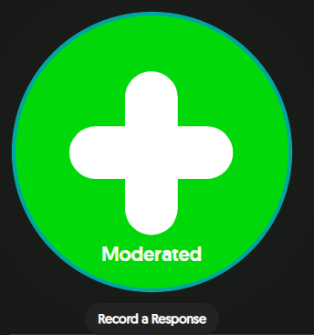
- Click this big green button to record!

Uploading A Video
- Press this button to begin recording your video:
- If you’ve previously recorded video, you can click the button to the right of the record button to upload other video.
- After you hit pause and finish recording, hit “next.” You can click and drag either end to edit the length of your video, or choose to go back and add more if you wish.
- Once you are satisfied with your video, hit “next” again. You will be prompted to take a selfie that will be used as the thumbnail for your recording.
- Next to the selfie you just took, you will see this on your screen:
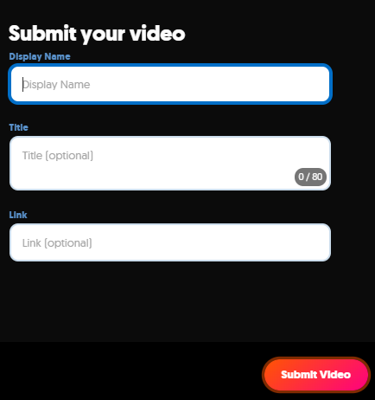
Please make sure you type your full first and last name for “display name.” Briefly describe your submission under “title,” and hit “submit.” That’s all there is to it!!
FAQ’s

- How do I access the Virtual Talent Show Flipgrid?
Click this link! Sroll down until you see the green circle with a plus(+). That’s what you click to get going on your recording.
- Who will be able to see my submission when I upload it?
Only the judging panel will be able to see all submissions when they are initially uploaded. Finalist videos will be made viewable publicly.
- Can I only record my video directly through Flipgrid?
No. You can pre-record your video on your device, and upload it when you get to the record (+) option. There will be an upload button next to the record button.
- How long do I have to record?
You have a maximum of five minutes for your recording. Flipgrid will automatically count down for you if you are recording directly through the site/app.
- Can I edit video directly on Flipgrid?
Yes, you can trim the length, add emojis, and draw on your videos, etc. Don’t be afraid to play around with it for a little bit before making your final video.
- Does Flipgrid have a phone app?
Yes. It is free to download from the app store. You can access our virtual talent show page by entering this flip code: bsmvirtualtalentshow

